F104401


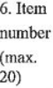 | 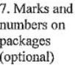 | 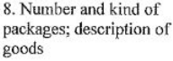 |  | 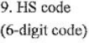 | 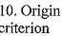 | 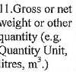
 |  |  |  |  | WO
13. |  |  |  | 14.

